자료구조론 CC343_2207
Programming assignment 5

경기대학교 컴퓨터공학부
201511837 이상민
Programming Example
1번 문제
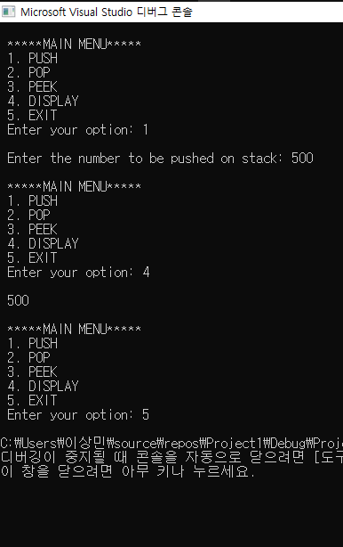
2번 문제
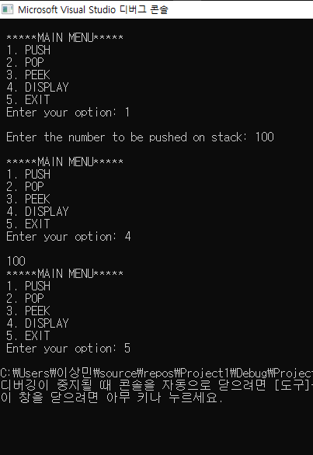

3번 문제
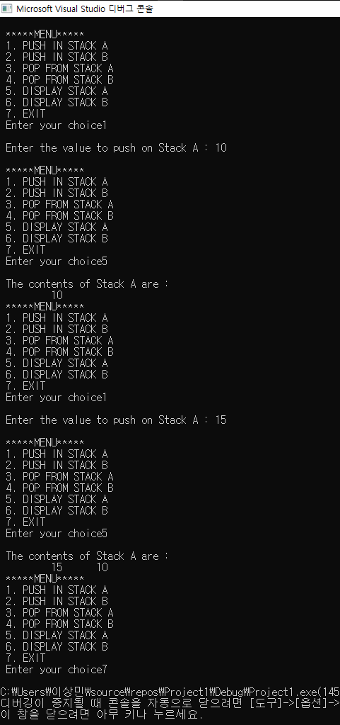
4번 문제
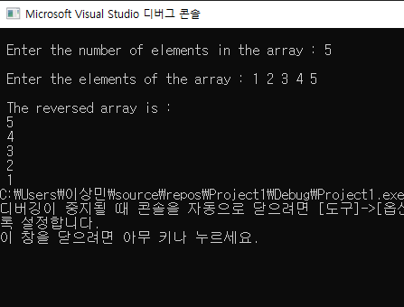
5번 문제
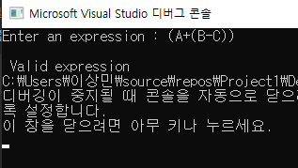
6번 문제
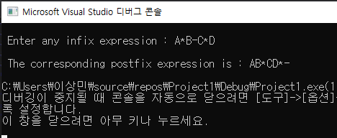

7번 문제
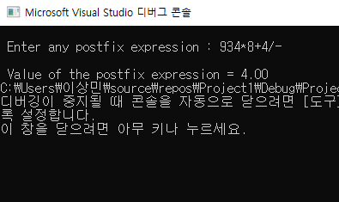
8번 문제
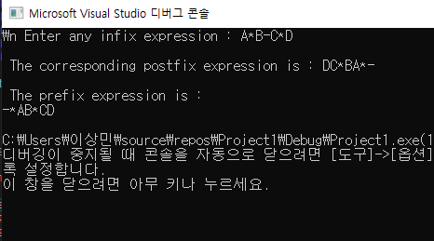
9번 문제
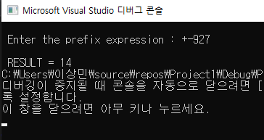

10번 문제
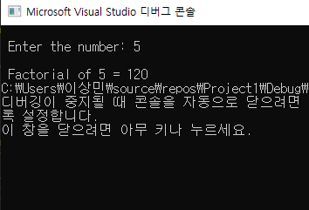
11번 문제
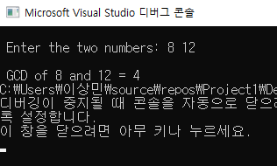
12번 문제
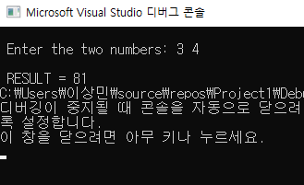
13번 문제
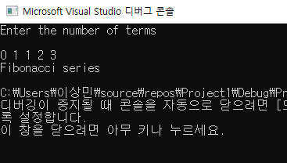
Programming Exercises
1. Write a program to implement a stack using a linked list.
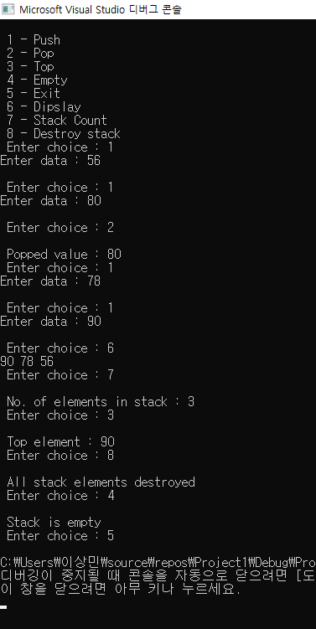

2. Write a program to convert the expression “a+b” into “ab+”.
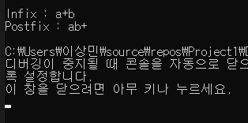
3. Write a program to convert the expression “a+b” into “+ab”.
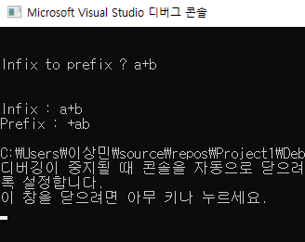
4. Write a program to implement a stack that stores names of students in the class.
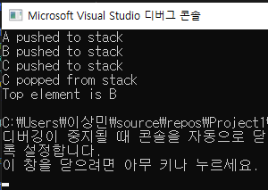

5. Write a program to input two stacks and compare their contents.
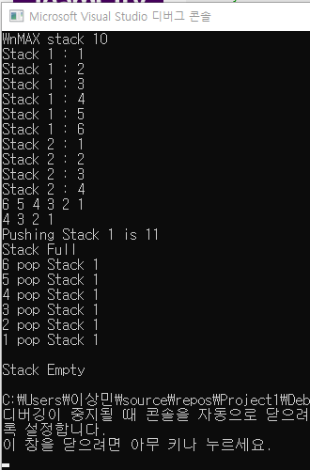

6. Write a program to compute F(x, y), where F(x, y) = F(x-y, y) + 1 if y<=x And F(x, y) = 0 if x<y
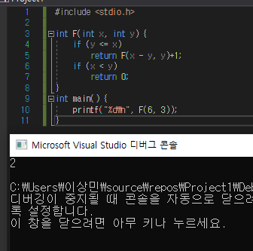

7. Write a program to compute F(n, r) where F(n, r) can be recursively defined as :
F(n, r) = F(n–1, r) + F(n–1, r–1)
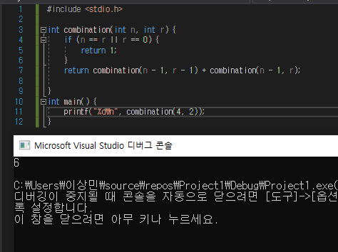

8. Write a program to compute Lambda(n) for all positive values of n where Lambda(n) can be recursively defined as :
Lambda(n) = Lambda(n/2) + 1 ( if n>1 )
and Lambda(n) = 0 ( if n =1 )
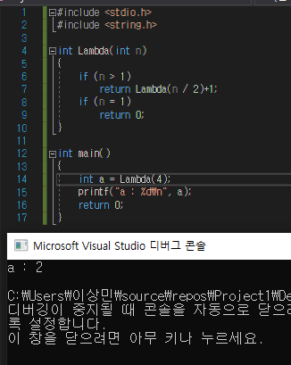

9. Write a program to compute F(M, N) where F(M, N) can be recursively defined as :
F(M,N) = 1 ( if M=0 or M≥N≥1 )
and F(M,N) = F(M–1,N) + F(M–1, N–1), otherwise
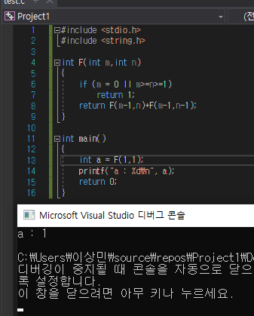

10. Write a program to reverse a string using recursion.
